# Ex.No-3 DATA VISUALIZATION

**AIM:**

To compute their sigmoid and tanh (hyperbolic tangent) values using NumPy and plot the values

# INTEGRATED DEVELOPMENT ENVIRONMENT (IDE) REQUIRED:

JUPYTER NOTEBOOK

# REQUIRED LIBRARIES FOR PYTHON:

* Numpy
* MatplotLib

# PROCEDURE:

Step 1: Import required libraries

Step 2: Write code to define the sigmoid function Define the tanh function Step 3: Write code to define the tanh function

Step 4: Generate a random array of values using numpy

Step 5: Calculate the sigmoid and tanh (hyperbolic tangent) of these random values Step 5:Plot the values

# PROGRAM:

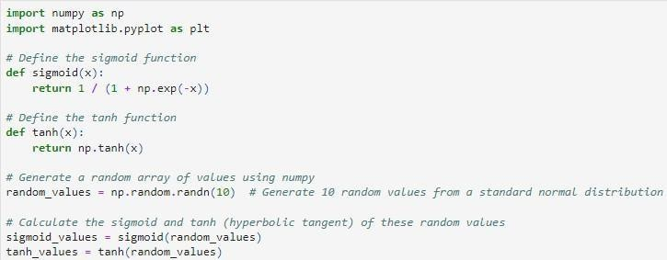

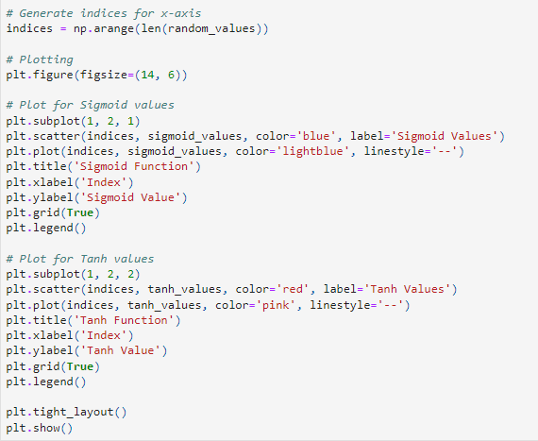

**OUTPUT:**

Output graph is plotted as below

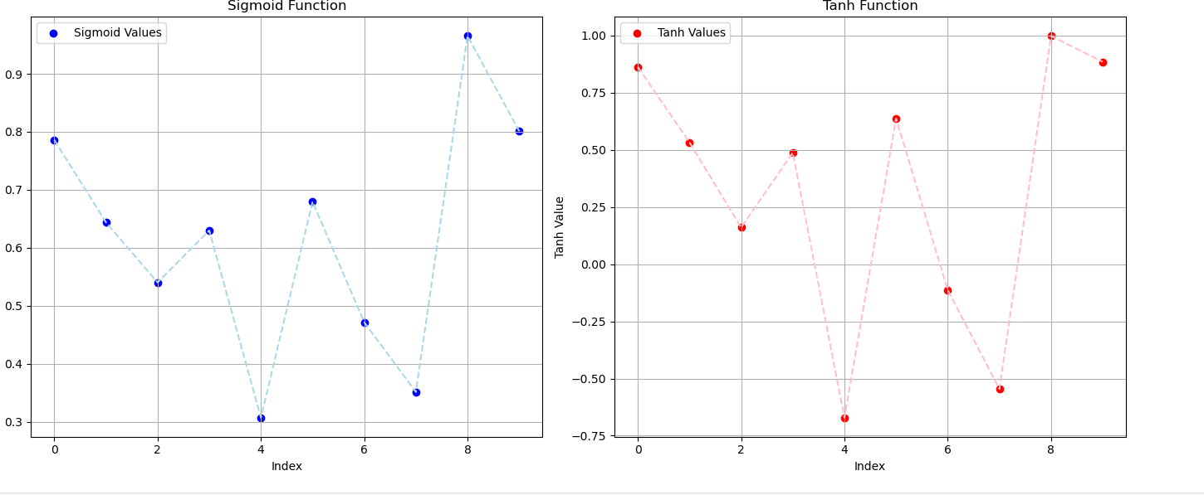

# Result:

The programs were run successfully